**Unveiling The Virtual Classroom: An In-Depth Analysis Of The Online Education System**

**Category: Data Analytics**

**Skills Required:**Python,Python For Data Analysis,Python For Data Visualization,Exploratory Data Analysis,IBM Cognos Analytics

**Project Description:**

Online classes and technology have emerged as a superhero during the lockdown days. We have all been under house arrest but are still connected with the world of education. Due to the lockdown, students have not been able to stay connected with the outer world and the lack of exposure is evident. The only reprieve for the students’ mental well-being has been the transition to online classes. Teachers made sure that the learning for students was not compromised, so they took a great leap forward to find solutions and create new learning environments for their students to ensure that learning never stops. With the rapid advancements in technology and the widespread availability of internet access, online education has gained significant popularity in recent years.

This project aims to delve deep into the various aspects of online education, examining its strengths, weaknesses, opportunities, and challenges. The outcomes of this project will provide valuable insights for educational institutions, policymakers, and online learning platforms to enhance the effectiveness and accessibility of online education. This analysis of the online education system aims to contribute to the ongoing dialogue on the future of education and help shape a more inclusive, engaging, and effective learning environment in the digital age.

**Technical Architecture:**

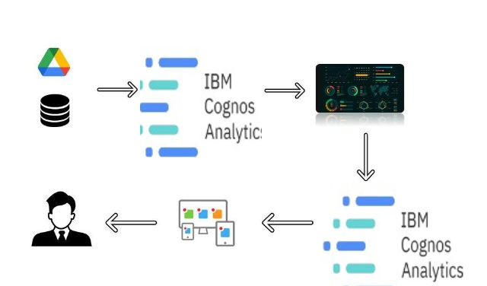

**Project Flow**

* Define Problem / Problem Understanding
  + Specify the business problem
  + Business requirements
  + Literature Survey
  + Social or Business Impact.
* Data Collection
  + Collect the dataset
  + Connect data with IBM cognos
* Data Preparation
* Prepare the Data for Visualization
* Data Visualizations
  + No of Unique Visualizations
* Dashboard
  + Responsive and Design of Dashboard
* Story
  + No of Scenes of Story
* Report
* Creating a report
* Performance Testing
  + Amount of Data Rendered to DB ‘
  + Utilization of Data Filters
  + No of Calculation Fields
  + No of Visualizations/ Graphs
* Web Integration
  + Dashboard and Story embed with UI With Flask
* Project Demonstration & Documentation
  + Record explanation Video for project end to end solution
  + Project Documentation-Step by step project development procedure

### Define Problem / Problem Understanding

### Introduction

### Online education system provides facility for delivering education through internet medium. The education content like document, video lectures, assessments are delivered. The main platforms used for lecture delivery are zoom, google meet, google classrooms, other tools like blackboard, moodle to provide lecture content. These tools also provide the engagement

### Specify The Business Problem

During covid 19 outbreak, the online education system has evolved like anything. All institutions adopted the online education delivery platform to their students. Various courses were delivered to the students through online education platform. Analyzing its efficacy is important for higher education system. The problem presented here reflect the analysis of online education system based on the data collected. The report presents the depth analysis to provide the important factors to take care off for enhancing the effectiveness and accessibility of the online education system.

*Keyword: Data Analysis, IBM Cognos, Data Visualization*

### Business Requirements

Business requirements for a problem statement like this would include taking student and teacher surveys, understanding student needs , and having an efficient feedback system. There is a need to update the content that is being taught to students based on the feedback .These requirements are necessary to ensure that students are able to find it easy to adjust with online education / e-learning. Specific requirements may vary depending on the student demographic, their needs and their interests.

### Literature Survey

### Social Or Business Impact.

**Social Impact:**Understanding the pros and cons of e-learning and making it better for future generations  
  
**Business Model/Impact:** Ed-tech companies and other organizations can capitalize on this